Ovid

In 43 BC - the year in which Cicero was executed and both consuls fell in the bitter civil war which followed Caesar's death - Publius Ovidius Naso was born at Sulmo in Umbria, a town 90 miles east of Rome. His father was a well-to-do member of the equestrian order who wished Ovid to undertake the study of rhetoric, which would have led to a career either in politics or in the law. But Ovid's lack of political ambition and his almost miraculous gift for versifying put paid to his father's hopes. In an autobiographical poem Ovid tells us:
quod temptabam scribere, versus erat
whatever I attempted to write down, turned out to be verse.
- in other words he claimed to be a natural poet. His first work Amores soon established him
as a leading poet in Rome and he devoted the rest of his life to his art. He married three times. His third wife was very loyal to him and stood by him when he lost the favour of the Emperor Augustus.

Very little of Ovid's love poetry had been written in the spirit of the moral reforms which the Emperor Augustus wished to introduce. Augustus was particularly keen to protect or restore the stability of Roman family life, whose strength and piety, in the Emperor's opinion, had been a major factor in the growth of Roman power and which he felt had been sadly undermined during the long periods of unrest and civil war. Other leading poets of the day, such as Virgil and Horace, had responded positively to the wishes of Augustus. Ovid, however, had not only failed to highlight the virtues of the old Roman way of life, but had given publicity in his love poems to a way of life which was the opposite of the Emperor's ideal. In AD 8, just as Ovid was finishing the sixth book of the Fasti, the terrible blow fell -Augustus issued a decree banishing Ovid to a small frontier town on the Black Sea. The town was Tomi, the modern Constanza, in Romania.

Ovid gives two reasons for his exile: a poem which he wrote (probably Ars Amatoria, which it was claimed had bad social and moral effects); and what he calls his error, which he fails to explain, but was possibly some indiscretion involving Julia, granddaughter of Augustus, who was exiled about the same time. The decree was final and Ovid died in Tomi in AD 18.
So Ovid died without books, without educated friends, without even a good Latin speaker to talk with, having memories only of the good old life in Rome. His fate has been compared to Oscar Wilde (1854 - 1900) in the Victorian era. But to his credit he continued to write poetry to his death. Finally he even accepted his lot and took a greater interest in the life of Tomi. He learned the local language and, being Ovid, began to write poetry in that language as well.
There is a terrible irony in the life of Ovid. The wealth and security that Ovid and his friends enjoyed in Rome had been won by ordinary Roman soldiers who, over many years, had led harsh and disciplined lives on the edges of the Empire. Only in the last ten years of his life did Ovid become aware of the price the soldiers had paid so that people such as he could live in luxury.

Ovid was convinced that his writings would be immortal. His birthplace, Sulmo, is now the modern town of Sulmona, in whose central square stands a statue of him with the inscription:
Paelignae dicar gloria gentis ego
I shall be called the pride of the Paelignian people
and the initials of his phrase Sulmo mihi patria est SMPE 'Sulmo is my birthplace' are used as the municipal motto. During the Middle Ages he was called the Teacher of Love, and in the Renaissance he was by far the most popular Roman poet.

Ovid's Poetry
Ovid's many works can be conveniently divided into three main groups as follows:

(i) Love Poetry - consisting principally of three works Amores, Heroides and Ars Amatoria, and completed before AD 2. These works are .witty, entertaining and sophisticated. They are said to show a remarkable grasp of female psychology, but, though Ovid shows pity for the people whose minds he is analysing, he also shows his readers how to take advantage of them so that he appears to us to be rather heartless at times at this stage of his career. The Heroides are love poems written in the form of imaginary letters in verse from various heroines of legend to their absent lovers or husbands.

(ii) Mythological Poetry - written between AD 2 and AD 8 and consisting of:
(a) Metamorphoses - Ovid's greatest and most influential work. It is a remarkable collection in 15 books of Greek and Roman myths in which the characters are 'metamorphosed' or transformed into a totally different form or shape, for example, into birds or trees. The period covered extends from the creation of the world down to the 'metamorphosis' of Julius Caesar into a comet after his assassination. This poem has been a rich source of inspiration for artists of all kinds, providing material for stories, plays, operas, paintings, sculptures and other poems up to the present day. It is also the most complete account we possess of the wonderful world of Greek mythology and for this reason is a priceless treasure which survives from the ancient world. The stories tumble out, one after the other, with an excellence that never flags.
(b) Fasti - in this work Ovid attempts to give the origins of the major Roman festivals, devoting a book to each month. Ovid weaves old stories and legends around the various feast days, making the work a vital source of Roman folk-legend, mythology, religion and customs. He recreates beautifully the atmosphere of rural Latium - its groves, springs, gods, nymphs and country folk. Because of his exile he failed to complete this work.

(iii) The Poems of Exile
(a) Tristia - consisting of 49 elegies in 5 books and (b) Epistulae ex Ponto - which are 46 letters in verse in 4 books. Both works consist, for the most part, of descriptions of his place of exile and of pathetic pleas to be recalled to Rome. They are full of depression and self-pity. There is a moving description of his last night in Rome, whose sophisticated pleasures he had to leave forever; also his touching autobiography. We feel genuine pity for the society poet in Tomi when we read of the terrible winters there, of barbarian invasions across the frozen Danube River with the ageing poet having to take his turn at sentry duty.

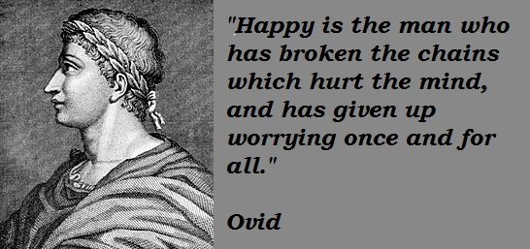

Ovid Fasti Book 4 Lines 425-544

Introduction
Venus, goddess of love, was determined to assert her power over all creatures, divine as well as human. She therefore commissioned her son Cupid to fire his sharpest dart into Pluto, god of the Underworld, and to make him fall passionately in love with Proserpine (Persephone in Greek), the young and innocent daughter of Ceres, goddess of fertility and growth.

Pluto saw the girl and carried her off into the kingdom of the dead. Meanwhile, the distraught mother searched the world over for her beloved child until she came to Sicily and saw the girdle of Proserpine's tunic floating on the waters of a lake. She still did not know where her daughter was and in her anger and frustration, she cursed the earth and made the harvests fail. Soon people were dying of hunger.

Finally, Arethusa, the river which flows partly beneath the earth, told Ceres that Proserpine was in the Underworld, ruling there as queen and consort of Pluto. Ceres went straight to Jupiter and demanded that Pluto give back her daughter. Pluto agreed, provided only thatProserpine had not tasted any of the food of Hades.

But Proserpine had unwittingly eaten some seeds of a pomegranate in Pluto's gardens and so, by the decree of the Fates, could never completely leave the Underworld. Eating the food of her host put her in his thrall, an idea common in myth.

Jupiter's solution was to divide the year in two. Proserpine spends half the year with her mother and half with her husband.

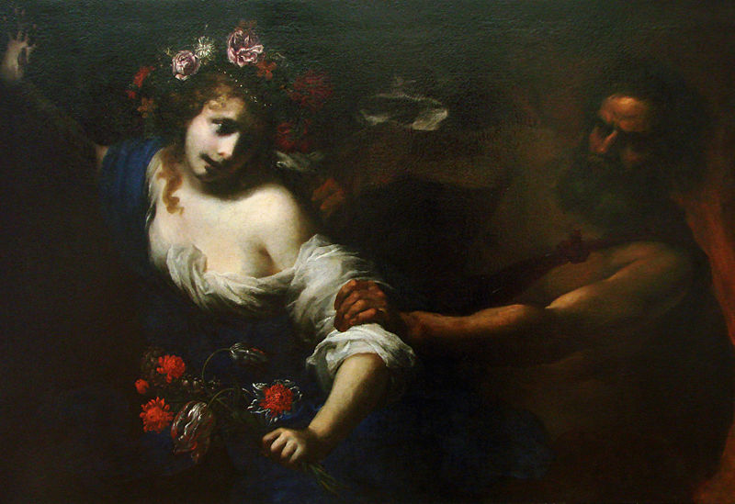
Ovid Fasti Book 4 Lines 425-544

XIV The abduction of Persephone

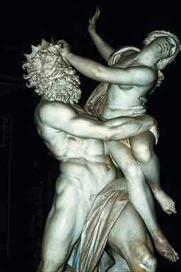
filia, consuetis ut erat comitata puellis,
errabat nudo per sua prata pede.
tot fuerant illic, quot habet natura, colores,
pictaque dissimili flore nitebat humus.
quam simul adspexit, 'comites, accedite' dixit
'et mecum plenos flore referte sinus.'
plurima lecta rosa est, sunt et sine nomine flores:
ipsa crocos tenues liliaque alba legit.
carpendi studio paulatim longius itur,
et dominam casu nulla secuta comes.
hanc videt et visam patruus velociter aufert
regnaque caeruleis in sua portat equis.

The Rape of Proserpina by Bernini - Galleria Borghese, Rome

Attended, as was usual, by her friends, her daughter wandered barefoot through the familiar meadows.
All the colours that nature possesses were (displayed) there, and the multi-coloured earth was gleaming with different flowers.
As soon as she saw it, she said, ‘Come here to me, friends, and with me, fill the fold of my garment with lapfuls of flowers’. Many a rose was picked, and flowers without a name.
(Persephone) herself plucked dainty crocuses and white lilies.
Intent on gathering, she gradually strayed afar, and it chanced that none of her companions followed their mistress. (Dis / Pluto: her uncle) saw her and no sooner did he see her than did he swiftly abduct her and carry her off on a dark horse to his realm.

Glossary:
1. consuetus: as usual
2. partum: meadow
4. pictus: multi-coloured dissimili: 'of various kinds' nitere: to gleam humus: ground
5. simul: as soon as
6. replere: to fill sinus: fold of garment
7. legere: to pick
8. carpere: to pluck 9. paulatim: gradually itur: from ire 'she went'.
9. casu: by chance
10. patruus: Pluto was Ceres' brother.
11. caeruleus: dark

Notes:
Note Ovid's choice of flowers for Persephone and their colours. The lily was a symbol of the Greek goddess Hera (Roman: Juno), again showing purity and innocence. One tale tells of lilies springing up from drops of milk spilled from Hera’s breast as she nursed Heracles. Another tells a story of how the lily acquired its pistil: as Venus rose from the ocean, she saw a lily and, jealous of the beauty of the pure-white flower, created an ugly pistil that came up from its centre, thereby marring its beauty. This story accounts for the lily’s additional association with fertility and eroticism. Lilies were associated with death as well, signifying that in death, one regained one’s lost innocence and purity.

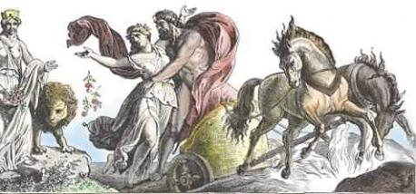

Ovid Fasti Book 4 Lines 502-3, 505-6, 511-14

XV Ceres searches for her daughter
Sic venit ad portus, Attica terra, tuos.
hic primum sedit gelido maestissima saxo.
sub Iove duravit multis immota diebus,
et lunae patiens, et pluvialis aquae.
filia parva duas redigebat rupe capellas;
et tener in cunis filius aeger erat.
‘mater,’ ait virgo, (mota est dea nomine matris)
‘quid facis in solis incomitata locis?’

Thus she came to thy harbour, land of Attica.
There for the first time she sat down, very sad, on the cold stone.
For many days she endured, motionless, under Jupiter (in the open)
Suffering both the moon and the rain water.
A little daughter drove two she-goats back from the mountain rock
And an infant son was sick in his cradle.
‘Mother,’ said the maid (the goddess was touched by the name of mother)
‘What are you doing all alone in solitary places?’

Glossary
venit: present historic tense. This is a common device in storytelling.
Gelidus: cold, icy
Saxum-i: stone
Maestus: sad
Sub Iove: under Jupiter, under the sky
Duro,-are,-avi,-atum: to endure/be patient/hold out
Patiens: enduring
Pluvialis aqua: rain water
Redigo,-igere,-egi,-actum: to drive back
Rupes, -is: rock/cliff
Capella: she goat
Tener, -i: young, weak, delicate
Cunae: cradle
Virgo, -inis: maid
ait: inquit 'said
Ovid Fasti Book 4 Lines 519-530

XVI Sympathy for Ceres
‘Sospes eas, semperque parens; mihi filia rapta est.
heu! melior quanto sors tua sorte mea est!’
dixit: et ut lacrimae, (neque enim lacrimare deorum est),
decidit in tepidos lucida gutta sinus.
flent partier molles animis birgoque senexque:
e quibus haec iusti verba fuere senis:
‘sic tibi, quam quereris raptam, sit filia sospes,
surge: nec exiguae despice tecta casae.’
cui dea, ‘duc,’ inquit, ‘scisti qua cogere posses.’
Seque levat saxo, subsequiturque senem
dux comiti narrat, quam sit sibi filius aeger,
nec capiat somnos, invigiletque malis

‘Be safe, and may a parent’s (joy) be yours forever. My daughter has been taken from me.
Alas! How much better is your fate than mine!’
She spoke, and like a tear, (for Gods can never weep)
A crystal clear droplet fell on her warm breast.
They wept together with her, those tender hearts, the man and the virgin girl:
Of whom these were the word of the righteous old man:
‘So may the ravished daughter whom you seek be restored safe to you;
Arise: and do not despise the shelter of my (humble) cramped abode.’
To him the goddess replied, ‘Lead on, you have found a way to force me.’
And she rose from the stone and followed the old man, the leader informed his companion how his son was sick
And unable to sleep and was kept awake by his nightmare
Glossary:
Sospes –itis (adj): safe and sound, lucky
Rapta est: rapto, are, avi, atum: sieze and carry off
Sors, sortis (f): fate
Ut: like
Gutta- ae: drop, spot
Sinus: breast
Flere (2): to cry
Pariter: together
Queri: to lament
Exiguus: cramped, small

Note: Ceres, in her search for her daughter, came across an old man who was on his way home after foraging for acorns and berries, and fetching dry wood for the fire. With him was his little daughter who was driving home two goats from the hill. His son was at home, sick in bed. Ceres was dressed as an old woman, so they did not know who she was. The little girl and her father stopped and tried to persuade Ceres to take shelter in their hut. She refused and told them that her daughter had been taken from her…

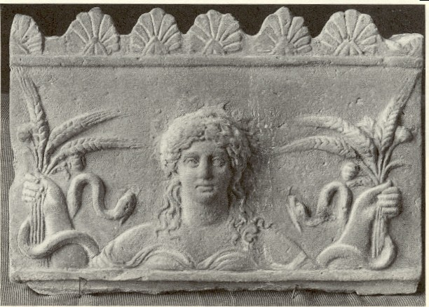

Ovid Fasti Book 4 Lines 537-44

XVII Ceres cures a sick boy
Limen ut intravit, luctus videt omnia plena;
iam spes in puero nulla salutis erat.
matre salutata (mater Metanira vocatur)
tangere dignita est os puerile suo.
pallor abit, subitasque vident in corpora vires.
tantus caelesti venit ab ore vigor.
tota domus laeta est: hoc est, materque paterque
natatque: tres illi tota fuere domus.

When she crossed the threshold, she saw the entire household full of grief
Now all hope of saving the child was gone
The mother was greeted (by the goddess) – the mother was called Metanira
(the goddess) deigned to put her lips to the child’s lips
His pallor fled and strength was suddenly visibly imparted to his body:
Such great energy flowed from divine lips
The entire household was joyful, that is the mother and father
And daughter, for these three comprised the entire household

Glossary
limen: threshold
luctus: grief
dignari: to deign, think it proper
pallor abit: This is a good example of Ovid's skill as a storyteller. Events follow swiftly upon each other.

Ovid Fasti Book 2 XVIII

Introduction

Arion was a famous lyric poet who came from Corinth, but made his fortune in Italy and Sicily. This story about his return to Greece is told by Herodotus in Book 1, chapter 24 of his Histories. Arion could even charm animals with the beauty of his music and song. After winning fame and fortune in Sicily and Italy, he boards a ship to return home to Corinth. He is attacked by the crew, who covet his wealth. He begs to be allowed to play a last tune, puts on a garland and leaps overboard. A passing dolphin is said to have rescued him.

Quod mare non novit, quae nescit Ariona tellus?
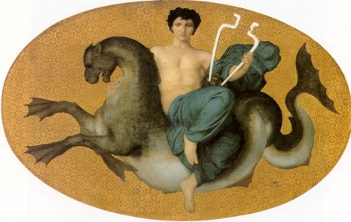
carmine currentes ille tenebat aquas
saepe sequens agnam lupus est hac voce retentus;
saepe avidum fugiens restitit agna lupum.
Nomen Arionum Siculas impleverat urbes;
captaque erat lyricis Ausonis ora sonis
inde domum repetens puppim conscendit Arion
atque ita quaesitas arte ferebat opes.

What sea does not know, what land does not know Arion?
By his song he used to hold back the running waters.
Often the wolf, while pursuing the lamb is held back by his voice;
Often the lamb hesitated while fleeing the greedy wolf.
The fame of Arion had filled Sicilian cities
and by the music of his lyre , he had charmed the Ausonion land.
Thence winding homewards Arion boarded a ship
and thus carried (with him) the acquired riches (won) by his art.

Glossary:
1. Ariona: Greek accusative of Arion.
Nescio –ire – ivi – itum: not know
Mare – is: sea
Tellus- telluris: land, earth, country

2. Carmen –inis: song, tune, verse
Ille – a – ud: he, that
Teneo – ere – ui: hold
Aqua – ae: water
3. saepe: often
Lupus –i: wolf
Sequens: following
Agna – ae: ewe lamb (You are probably more used to seeing ‘agnus’ as in ‘agnus Dei’: the lamb of God. ‘Agna’ just means a female lamb.)
Retentus: ppp of retineo – inere, -inui, -entum: to hold back or restrain

4. avidus: greedy, eager, hungry
Fugiens (fugio): fleeing
Restito – are: hesitate, stay behind
Implere: fill

5. Arionium: adjectivalhere.
Siculas... urbes: 'Sicilian cities'.

6. capta (capere): captivate or charm
Lyricus: of the lyre
Ora –ae: land, country, coast
7. inde: from there, thence
domum: Arion was returning home to Corinth from Italy and Sicily.
repetens: 'making for home again'.
Puppis –is: ship
Conscendo – ere, - endi, -ensum: to embark, board a ship
Atque: and (then)
Ita: thus
Fero (ferre, tuli, latum): to carry, carry off
Quaesitae opes: acquired riches

Ovid Fasti Book 2 Lines 97-100, 103-106, 111-116

Fortisan, infelix, ventos undasque timebas;
at tibi nave tua tutius aequor erat.
namque gubernator destricto costitit ense,
ceteraque armata conscia turba manu.
ille metu vauus, ‘mortem non deprecor,’ inquit,
‘sed liceat sumpta pauca referre lyra.’
dant veniam, ridentque moram. capit ille coronam
quae posit crines, Phoebe, decere tuos.
protinus in medias ornatus desilit undas.
spargitur impulsa caerula puppis aqua.
inde (fide maius) tergo delphina recurvo
se memorant oneri supposuisse novo.
ille sedens citharamque tenet, pretiumque vehendi
cantat, et aequoreas carmine mulcet aquas.

Perhaps, poor wretch, you feared the winds and the waves,
But (in truth), the sea was safer for you than your ship.
For the helmsman took his stand with a drawn sword,
And the rest of the guilty crowd had weapons in their hands
Quaking with fear he said: ‘I do not argue against death’
But let me be permitted to take up my lyre and play a little’.
They gave him permission and laughed at the delay. He took the crown
That Phoebe might well grace thy hair;
At once, with all his finery he leaped down into the might of the waves
The speeding ship is splashed by the blue water.
Therefore they say (it sounds) beyond belief, a dolphin (placed his) arched back
To carry the new, unusual burden
Seated there, Arion grasped his lyre, and paid his fare in song
And with his chant he charmed the ocean waves.

METRE: ELEGIAC COUPLETS
Ovid tells the story of Arion to explain the Dolphin constellation which rises on the third day after the Nones of February. Seu fuit occultis felix in amoribus index,/Lesbida cum domino seu tulit ille lyram. '(He, i.e. the dolphin, was raised into heaven) either because he was a lucky go-between in love's intrigues, or because he carried the Lesbian lyre and the lyre's master (i.e. Arion).' In the first two lines the poet addresses Arion directly and then returns to the third person narrative. The first person address adds immediacy and realism to the lines.

Glossary
2. nave tua: ablative of comparison.
3. constitit: 'took his stand'.
4. conscia turba: 'the conspiring gang' .
armata... manu: '(had) weapons in their hands'.
5. metu vacuus: another reading has metu pavidus 'quaking with fear'. Which is the more effective? Along with the address to Arion in the first two lines, the direct speech put into his mouth here has the effect of engaging our sympathies for Arion.
6. sumpta lyra: ablative absolute: 'having taken up my lyre'.
7. Brief sentences sketch in the action.
8. Phoebe: Phoebus (Apollo) is the god of music and poetry. Notice how the god is directly addressed by the poet. It is a means of praising Arion to suggest that his garland would also grace the hair of the god of music.
9. Notice how the words to describe Arion -ornatus desilit - are surrounded by the words for the waves -in medias... undas - imitating the way Arion, in jumping down, is surrounded by the waves of the sea.
10. impulsa aqua: ablative: 'with the splash'.
11. fide maius 'it sounds past credence' . Ovid disarms criticism by himself suggesting that the story is incredible and at the same time emphasises its marvellous nature.
delphina: accusative singular
12. memorant: 'they say' - here too the poet distances himself from the story he tells.
oneri novo: 'to a new (unusual) weight load'.
13. pretiumque vehendi (cantat): 'he paid his fare (in song)'.

Ovid - Heroides

Introduction
The Heroides, also known as the Heroines, the Letters of the Heroines or simply as Epistles are a very famous collection of poems by Ovid, not only for their interesting subject - letters by famous mythological characters addressed to their beloved ones - but also because it's considered by some the first example of the Epistle as a literary genre - a statement made by Ovid himself in his Ars Amatoria. The book as we have it nowadays consists of 21 letters, divided in two parts. The first is composed of fifteen letters presented as if written by a female mythological character to her lover; the second part, also known as Double Heroides, brings three pairs of letters, being the first in each pair supposedly written by a hero, and the second one, the heroine's response to the first letter. Along the Metamorphoses and the Ars Amatoria, the Heroides were one of the most influential works of Ovid, not only in the Antiquity, but also throughout the Middle Ages and up to Modern times.

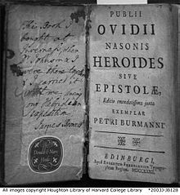

Ovid Heroides Lines 33-41

Introduction:
Danaus and Aegyptus, descendants of Io, quarrelled and as a result Danaus fled from Egypt with his fifty daughters. He came to the Greek city of Argos where he was made king. However, the fifty sons of Aegyptus pursued the daughters of Danaus with the intention of claiming them as their brides. Danaus was forced to agree to these marriages, but he ordered his daughters to stab their husbands on their wedding night. They all obeyed except Hypermnestra who spared her husband Lynceus. The women who had killed their husbands were later condemned in Hades to fill with water and carry jars with holes in them.

XX The murder of Lynceus’ brothers
Iamque cibo vinoque graves somnoque iacebant,
securumque quies alta per Argos erat.
circum me gemitus morientum audire videbar:
et tamen audieram quodque verebar, erat.
sanguis abit; mentemque calor corpusque relinquit;
inque novo iacui frigid facta toro.
ut leni Zephyro graciles vibrantur aristae,
frigid populeas ut quatit aura comas,
aut sic, aut etiam tremui magis.

And now heavy with food and wine they lay in sleep
And deep repose had settled on Argos, free from care,
(When) round about me I seemed to hear the groans of dying men
I heard indeed, and what I found was true.
My blood retreated and warmth left my body and soul,
And on my newly-wedded bed all cold I lay
As the gentle Zephyr sets a-quiver the slender stalks of grain,
As wintry breezes shake the poplar leaves
Even thus – even more did I tremble.

Glossary:
Lynceus: One of the Argonauts in Greek mythology. His eyesight was so keen he could see through the earth.
2. securus: free from care
Argos: in Homeric poems, this was the whole of the plain of Argolis, bounded on the north by mountains and on the south by the sea and containing Mycenae and Tiryns.
Quies: slumber
3. morientum: genitive plural of present participle.
videri: in passive 'to seem'.
4. audieram: audiveram.
Verere: to fear
5. abit..relinquit: change to present tense to heighten the tension, known as the historic present.
6. torus: bed
7. Zephyro: Zephyrus is the personification of the west wind in Greek mythology.
Aristae: ears or heads of corn
8. aura: wind
comae: leaves (hair)

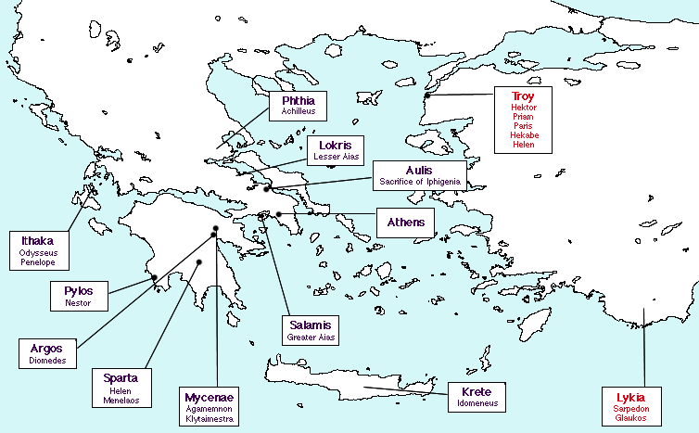

Ovid Heroides Lines 41-50

XXI Hypermenstra saves her husband
Ipse iacebas
quaeque tibi dederam, plena soporis errant.
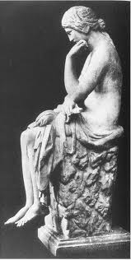
excussere metum violent iussa parentis:
erigor, et capio tela tremente manu.
non ego falsa loquar; ter acutum sustulit ensem,
ter male sublato recidit ense manus
admovi iugulo (sine me tibi vera fateri)
admovi iugulo tela paterna tuo.
sed timor et pietas crudelibus obstitit ausis,
castaque mandatum dextra refugit opus.

You were lying down,
And (the wine) which I had given you was heavy with sleep.
(The thought) of my violent father’s mandates drove away my fear.
I am moved to action and clutch the steel with trembling hand.
I will not speak any untruth; three times (did my hand ) rise high the piercing sword
And three times having sadly raised it the sword fell down
I brought it to your throat (let me confess to you the truth).
I brought my father’s weapon to your throat,
But fear and tenderness prevented me from undertaking the cruel task
And my pure right hand refused the task required

Glossary

2. plena soporis: literally 'full of sleep'.
3. excussere: poetic form of excusserunt. excutere: to drive away
4. erigor….capio: historic presents. erigi: to be moved (to action)
5. ensis: sword
Recidere: fall down
Fateri: to confess
7. (sine me tibi vera fateri): This aside lends a touch of realism to the manner in which the story is being told.
9. ausum: daring deed, undertaking
10. castus: pure
mandare: to entrust
refugere: to shun

